Phase 1: Phishing Detection Performance
This first set of charts visualizes the performance of the primary phishing detection model, which classifies emails as either legitimate ("Ham") or "Phishing".
Confusion Matrix for Phishing Detection
This heatmap provides a direct look at the model's classification accuracy across the test dataset. The main diagonal shows the number of correct predictions, while the other cells show errors. The model correctly identified 15,540 ham emails and 16,783 phishing emails, demonstrating a very low number of misclassifications.
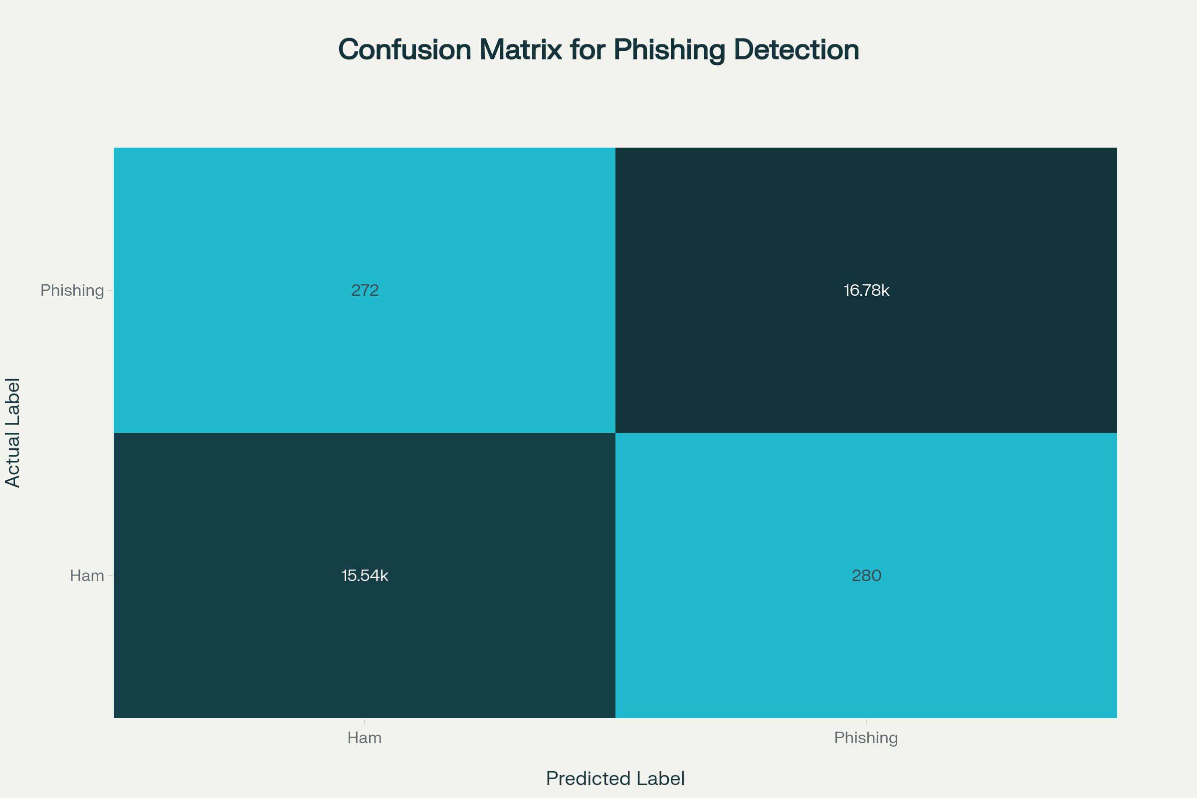
Confusion matrix heatmap showing classification performance of the phishing detection model.
Phishing Detection Performance Metrics
This chart breaks down the key performance metrics—Precision, Recall, and F1-Score—for both classes. The consistently high scores (all above 98%) indicate that the model is well-balanced. It is highly precise in its predictions, minimizing the risk of blocking legitimate emails (false positives), and has excellent recall, meaning it successfully identifies the vast majority of actual phishing threats (minimizing false negatives).
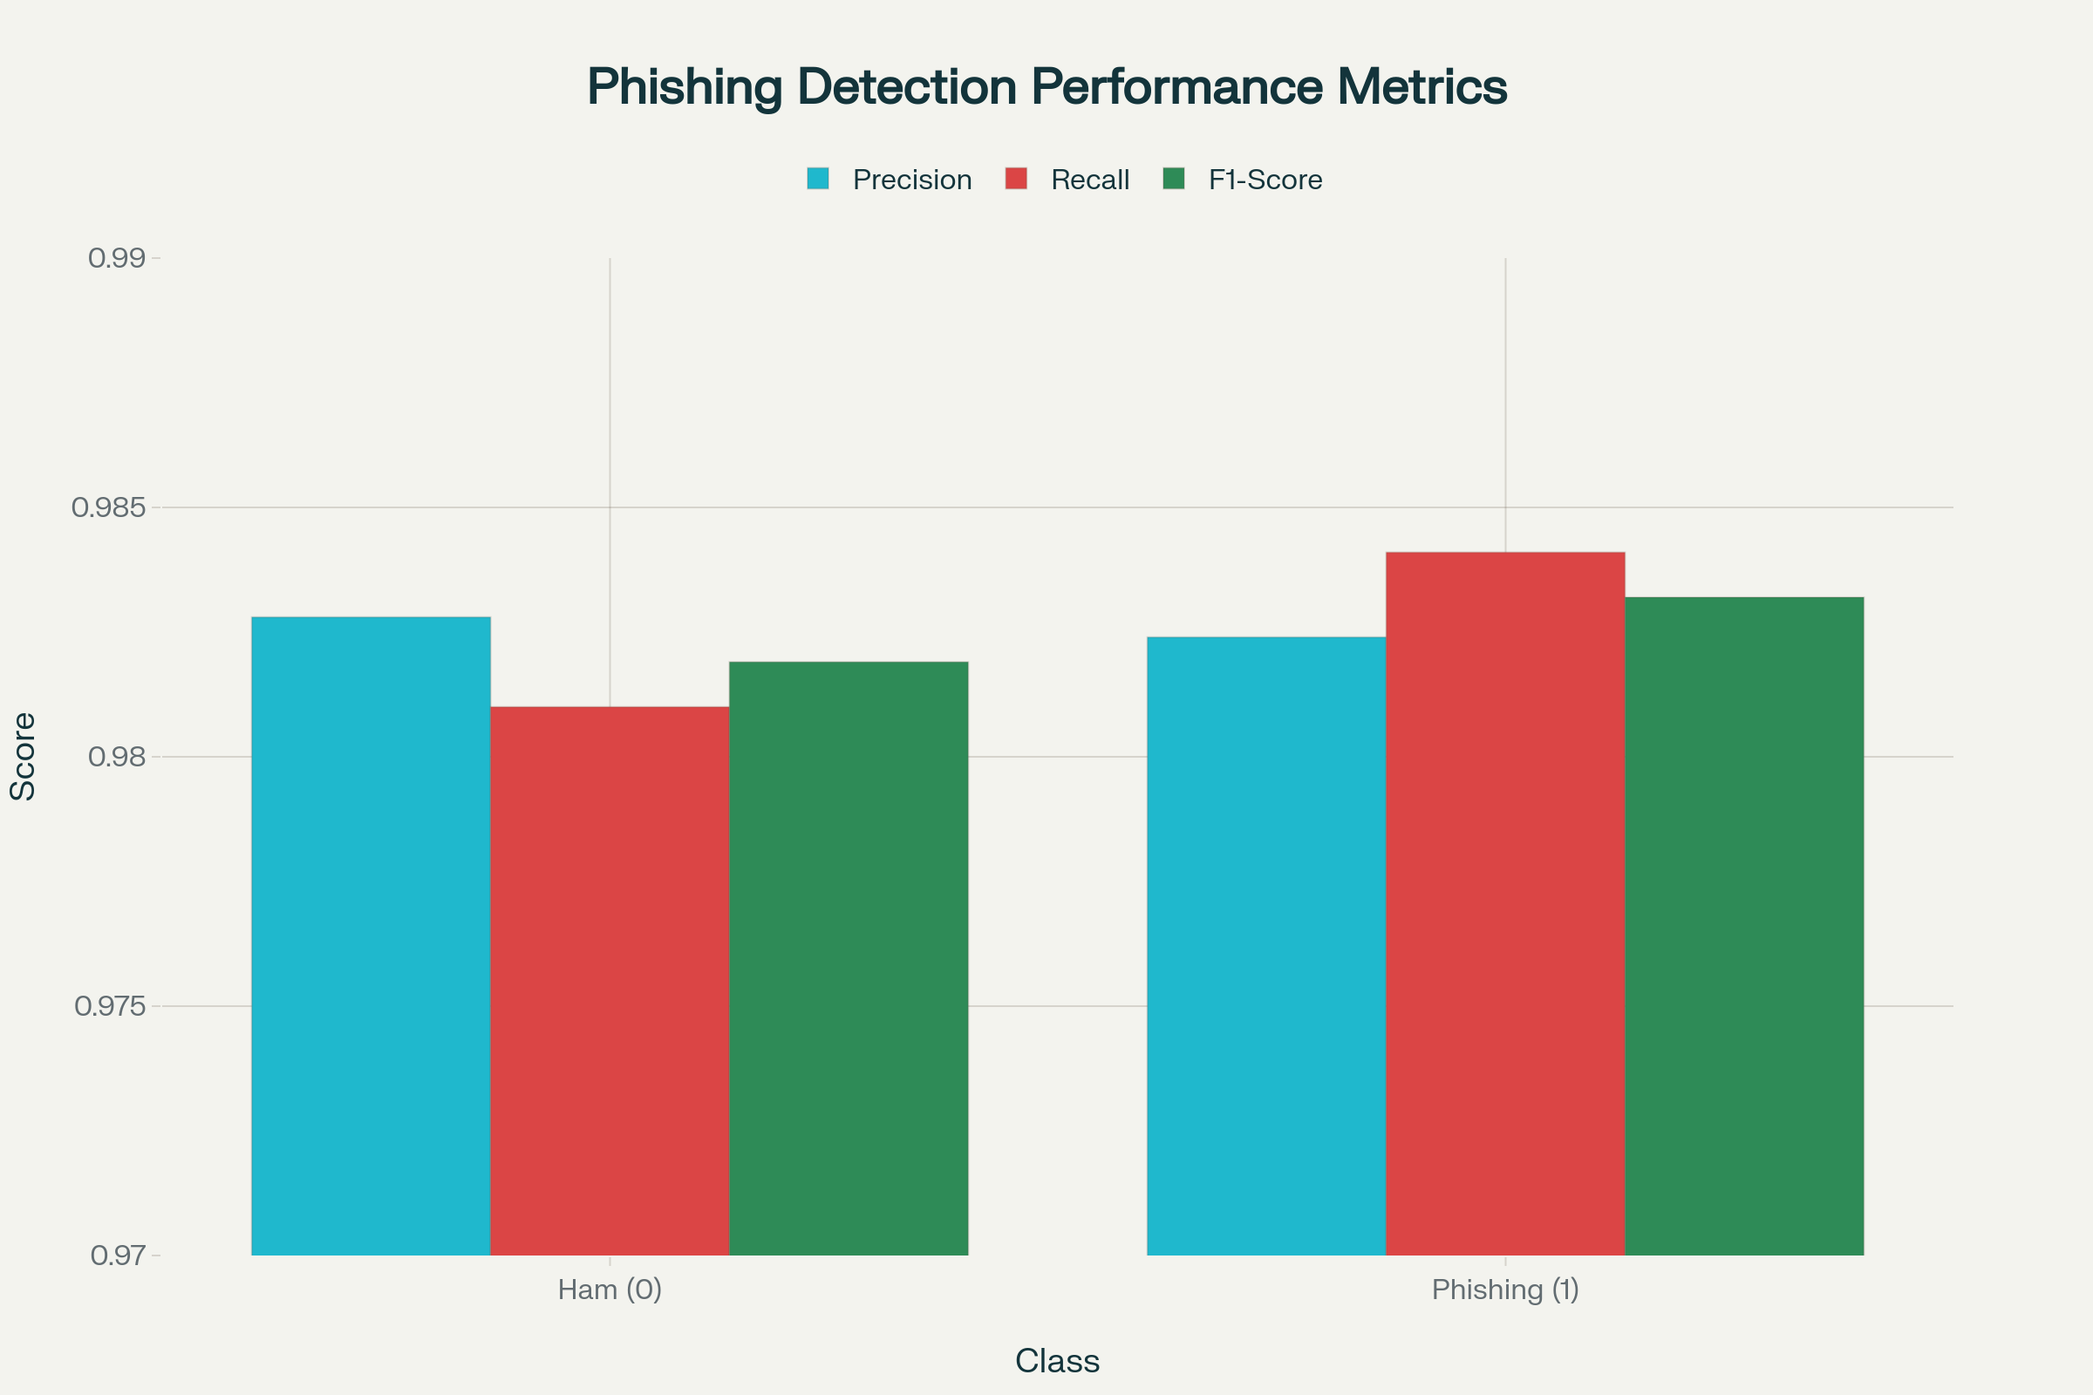
Bar chart showing precision, recall and f1-score metrics for each class in phishing detection model.
Phase 2: Intent Classification Performance
This chart evaluates the second phase of your pipeline: classifying the specific goal of an email that has already been identified as phishing.
Intent Classification Performance Metrics
This visualization shows how accurately the model identifies different types of phishing attacks, such as "Credential Harvesting" or "Financial Fraud." The model shows excellent performance, with near-perfect scores for most categories. The slightly lower recall for "Malware Delivery" (90%) is still strong but highlights a potential area for future model tuning. Overall, these results validate the system's innovative capability to provide fine-grained threat intelligence.^{[5][3]}
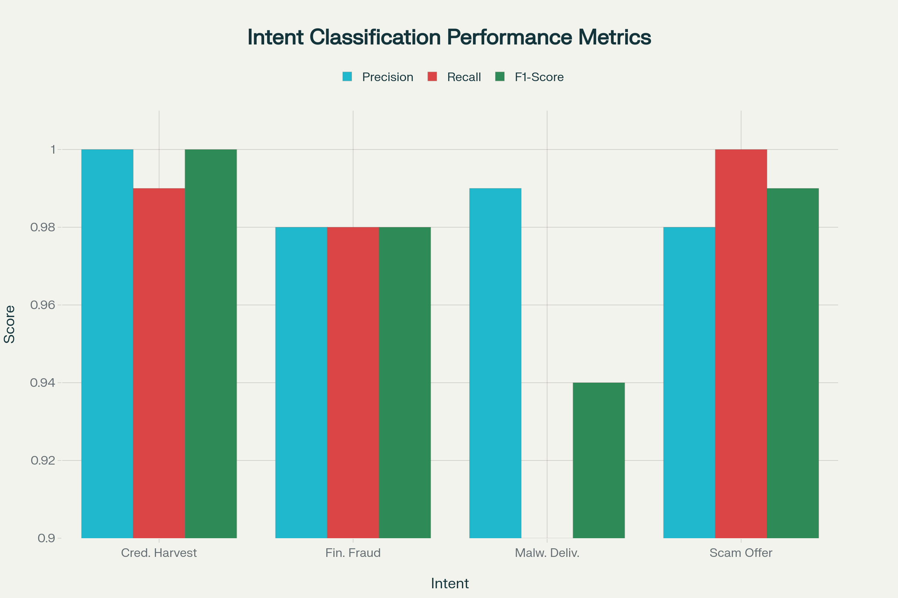
Bar chart showing precision, recall and f1-score metrics for each intent in the phishing intent classification model.
⁂

- DefenseGPT-Phishing-detection-Using-ML-1.pptx
- autoannotate_intent.py
- combined.py
- intent_classification_report.txt
- mlmodel_gpu_logging.py

